This is a sample of the resources Legato Strategic Consulting provides through dedicated support to institutions like yours.

Building and Editing User Experiences in Workday

Use this guide to create user experiences in Workday for staff, students, and faculty to reduce clicks and maximize use of the system.

In this guide, you will learn:
- User navigation options available in Workday
- How to create and manage custom dashboards
- Configuring Global Navigation
- Creating and managing bulletin worklets for the best user experience
Note: Screenshots for this guide are taken from work done at Legato customers

USER NAVIGATION OPTIONS
There are two main approaches to designing user navigation in Workday: Hubs and Dashboards.
- Hubs are owned and managed by Workday, which controls their content. Custom items often do not display well in this format.
- Dashboards offer much more flexibility. Workday-delivered dashboards can be customized but are limited to a single tab. In contrast, custom dashboards can be fully tailored to meet your needs.
Hub Example
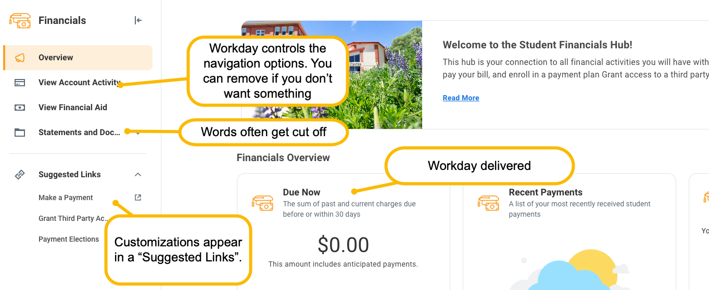
Student Dashboard Example

CHALLENGE
EIB templates can become outdated if the system changes (for example, if fields are added or renamed). Before importing data, always double-check you are using the most up-to-date version. The more time since the EIB template’s last update, the more likely it will fail.
Time Since Last Update | Likelihood of EIB Failure | Notes
0-6 Months | Low | Generally stable unless BP or security changed.
6-12 Months | Moderate | One major Workday release could have introduced breaking changes.
12+ Months | High | Multiple releases may have deprecated fields or changed behaviors.

UPDATE THE DEFAULTS IN THE TEMPLATE
- To locate the EIB Template, go to View Integration System
- Enter “INTSYS: [EIB name]”
- Locate and view the report with all your integration systems. Note: This should contain the date of last update to help determine whether a new update is needed)
- Click “Related Actions”
- Click “Template Model”
- Click “View”

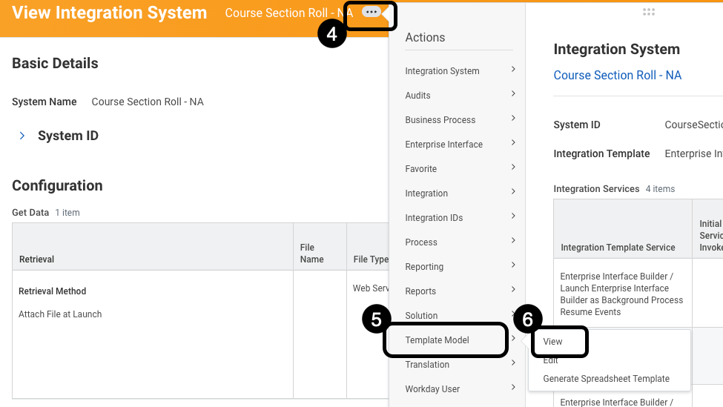

- Click “Edit Template Model Sheet”. A series of rows and columns will display the current defaults
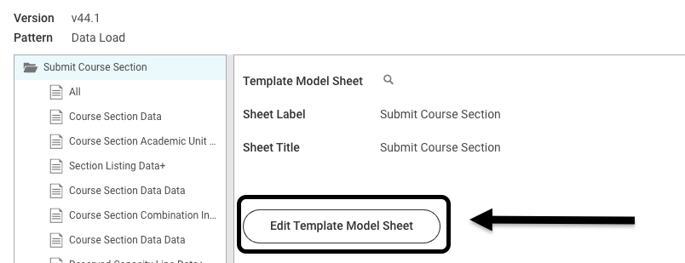

- Review and update the following fields.

Template Model Area Label: Course Section Academic Unit Data+
Label | Course Section Academic Unit Data
Column “Label” | Academic Unit
Change Reference ID column from: |  | Academic Unit Hierarchy
Change Reference ID column to: |  | Academic Unit ID
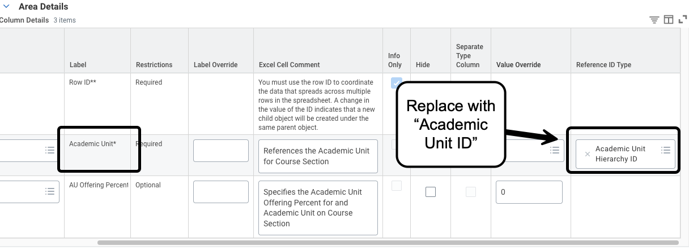

Template Model Area Label: Reserved Capacity Line Data+
Label | Reserved Capacity Line Data
Column “Label” | Reserved Capacity Line Eligibility Rule
Change Reference ID column from: |  | Application Additional Education Interest Eligibility Rule ID
Change Reference ID column to: |  | Eligibility_Rule_ID
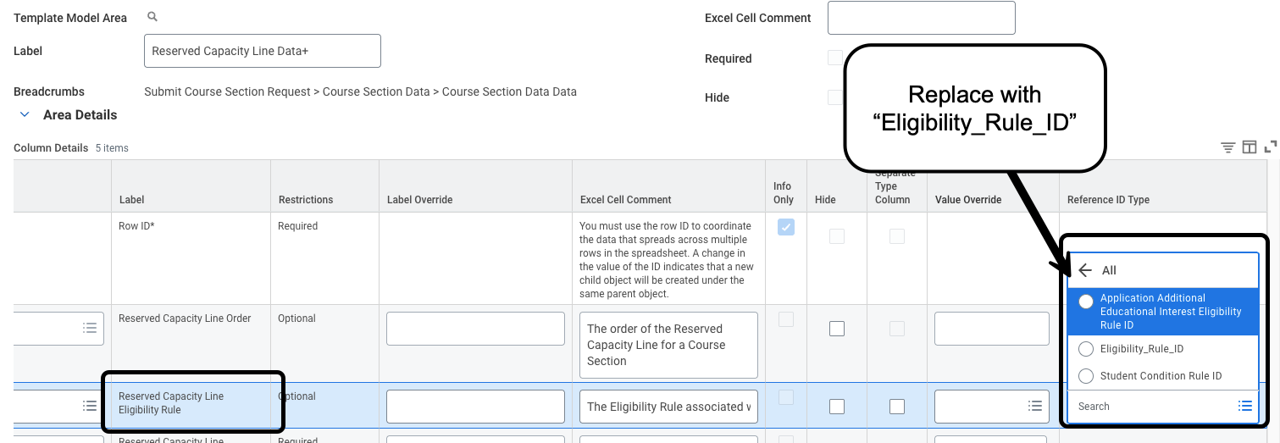

Template Model Area Label: Instructor Role Assignment Data +
Label | Instructor Role Assignment Data +
Column “Label” | Assignees to Add+ / Assignees to Remove+
If you want to change instructors, change Reference ID column from: |  | Academic Affiliate ID
Change Reference ID column to: |  | Employee ID
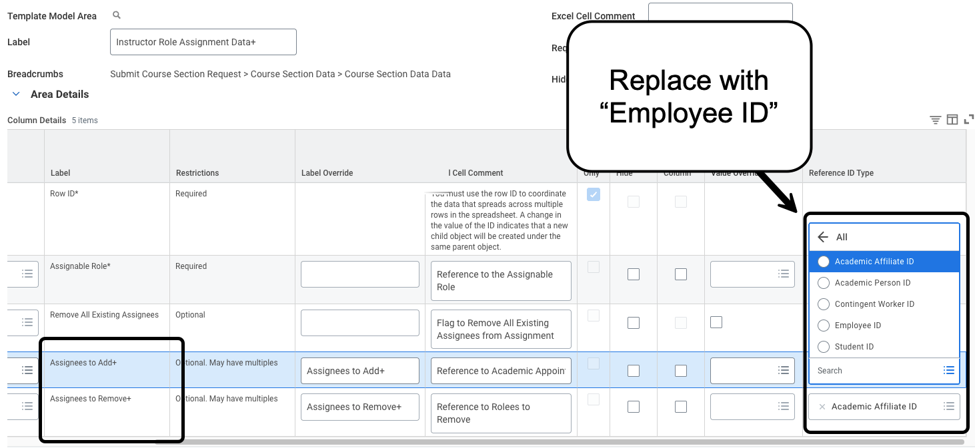
Template Model Area Label: Course Section Data Data
Label | Course Section Data Data
Column “Label” | Student Eligibility Rule
Change Reference ID column from: |  | Application Additional Education Interest Eligibility Rule ID
Change Reference ID column to: |  | Eligibility_Rule_ID
